Chapter 11, Solution 97

A power transmission system is modeled as shown in Fig. 11.99. If V_{s} = 240 ∠0° rms, find the average power absorbed by the load.

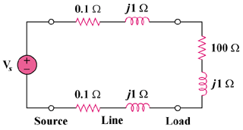

Figure 11.99
For Prob, 11.97.

Solution

